**Lab 1 Report**

**Title:** Comparison of three different API

**Notice:** Dr. Bryan Runck

**Author:** Liang-Ting Chen

**Date:** Feb 10, 2021

**Project Repository:**

<https://github.com/chen6761/GIS5572>

**Abstract**

In the lab, I compare and contrast the conceptual models from three different APIs. There are Minnesota Geospatial Commons, Google Places, and North Dakota Agricultural Weather Network (NDAWN). Then, I write a code in Jupyter Notebooks for each API to catch their data programmatically.

**Problem Statement**

In the lab, I focus on the models for the different APIs and the way to get their data through the programming.

First, I try to draw the conceptual models for each API to find the difference between them. Then, I analyze the website with the conceptual models I did to find their organization. After that, I write the code for each of them in the Jupyter Notebooks to get the data by programming.

**Input Data**

In the lab, I follow the instructor to use Minnesota Geospatial Commons, Google Places, and NDAWN as the targets to do my analysis. The table below shows the link of them.

Table. The input data

|  |  |  |  |
| --- | --- | --- | --- |
| **#** | **Title** | **Purpose in Analysis** | **Link to Source** |
| 1 | Minnesota Geospatial Commons | Make the conceptual models and catch their data programmatically | [MNGeo](https://gisdata.mn.gov/content/?q=help/api) |
| 2 | Google Places | [Google Places](https://developers.google.com/places/web-service/overview) |
| 3 | NDAWN | [NDAWN](https://ndawn.ndsu.nodak.edu/) |

**Methods**

**Minnesota Geospatial Commons**

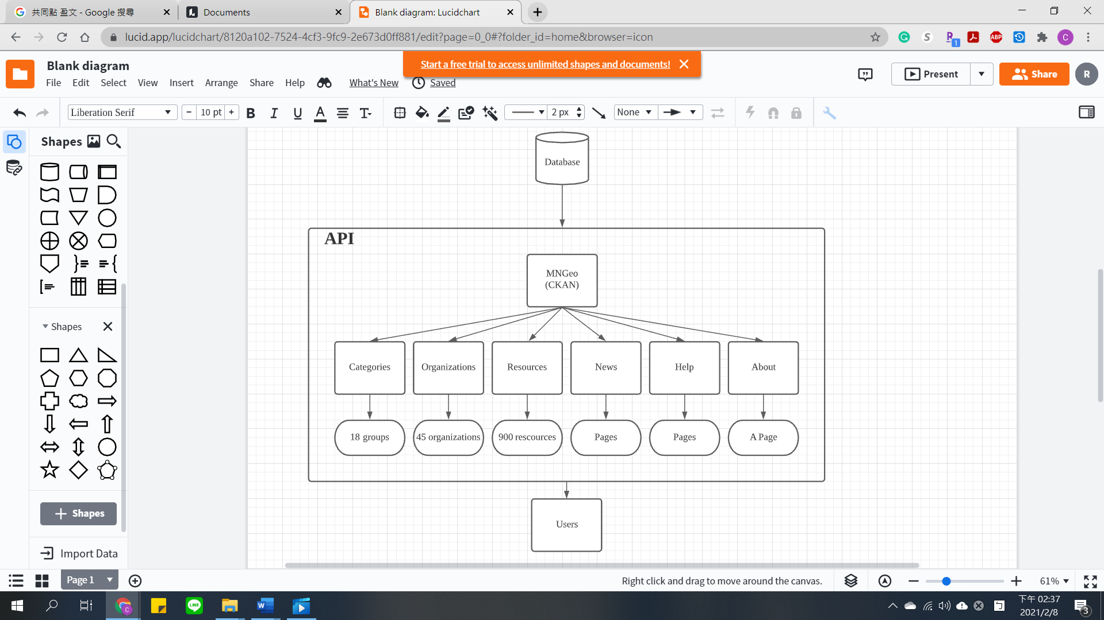

**Google Places**

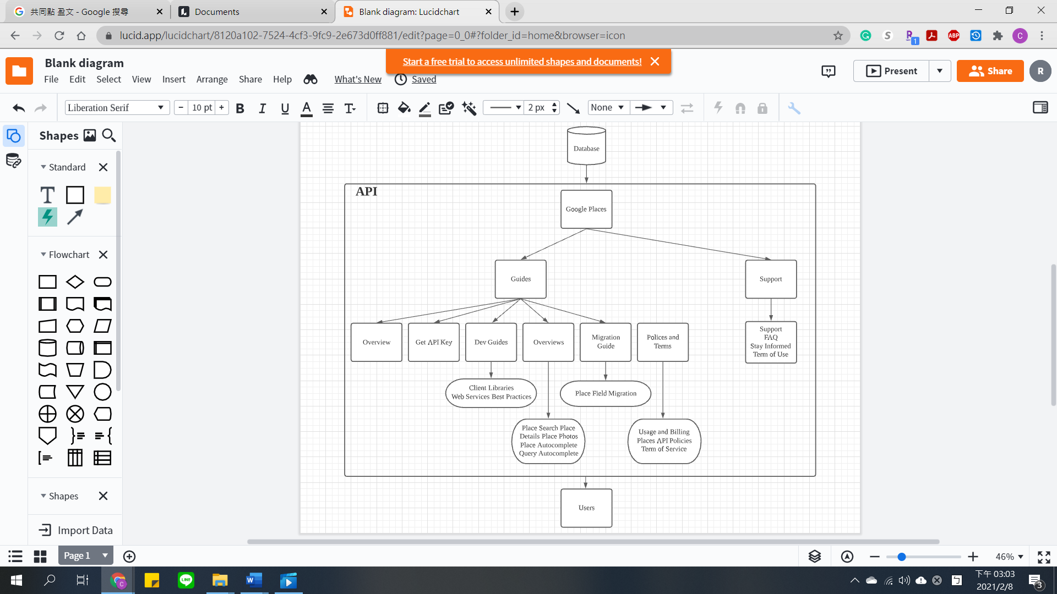

**NDAWN**

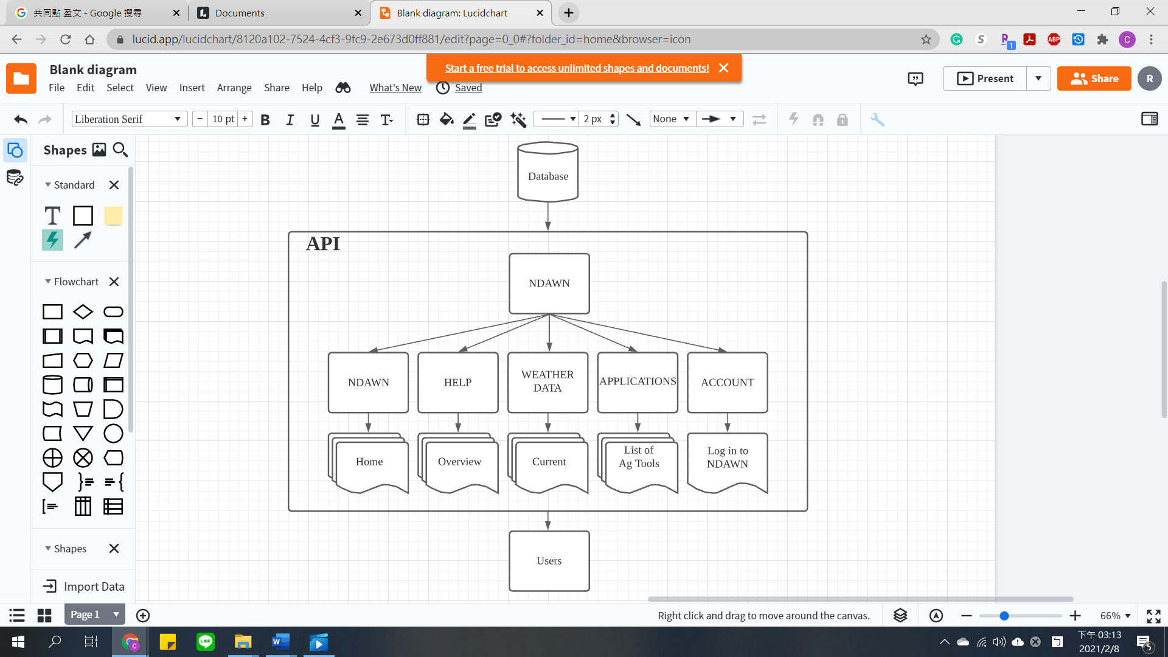

**Results**

|  |  |  |  |  |
| --- | --- | --- | --- | --- |
|  | Document | Account | Export Table | Download |
| MNGeo | V |  |  | V |
| Google Places | V | V |  | V |
| NDAWN | V | V | V | V |

All of the APIs are easy to read, and users can understand their functions clearly because they have documents to introduce their usage. Besides, users can download the data they need via these APIs, something special is that Google Places provides API Keys for users to apply in their work; MNGeo and NDAWN provide more intuitive data for users. The difference between these API is that one of them can export the .csv files (NDAWN), some of them include the account certification (NDAWN and Google Places), and one of them build its API via CKAN that users can catch data from it based on their code. (MNGeo)

**Results Verification**

Take the conceptual models above as a reference, I write the codes to get the data from each API programmatically. In this part, I learned how to use the parsing tools and understand the relationship between the API and codes.

**NDAWN**

In this API, the searching result shows on in the URL, like the “station=65&begin_date=2020-01&count=24&quick_pick=&ttype=monthly”, and I can change some intuitive variable to get the data I want. Then, I use beautifulsoup to analyze the script code behind the API and find the URL for the “Export CSV File”. (Wang, 2018) After combining the home page URL and the downloading URL, I can save the searching result as a CSV file to my local computer.

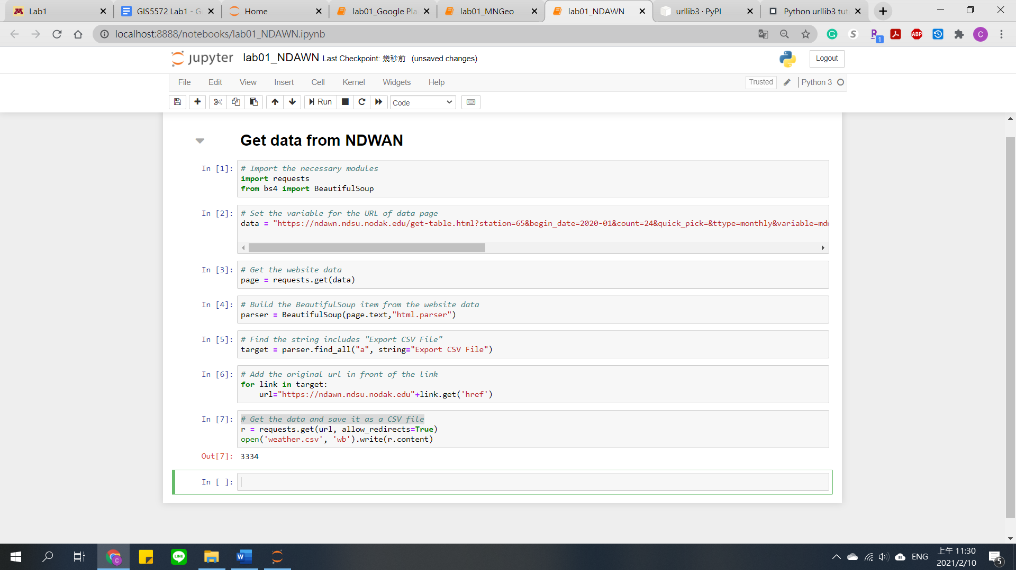

**MNGeo**

I change the way to read the website data. In the NDAWN, I used requests.get(data), however, I meet some SSL problem and decide to change a method to get the website data. After googling the question, I find I can use the urllib module to get the data as well. (Bodnar, 2020) This time I find the shapefile downloading link is under a class, and I use the same way to save it as a zip file.

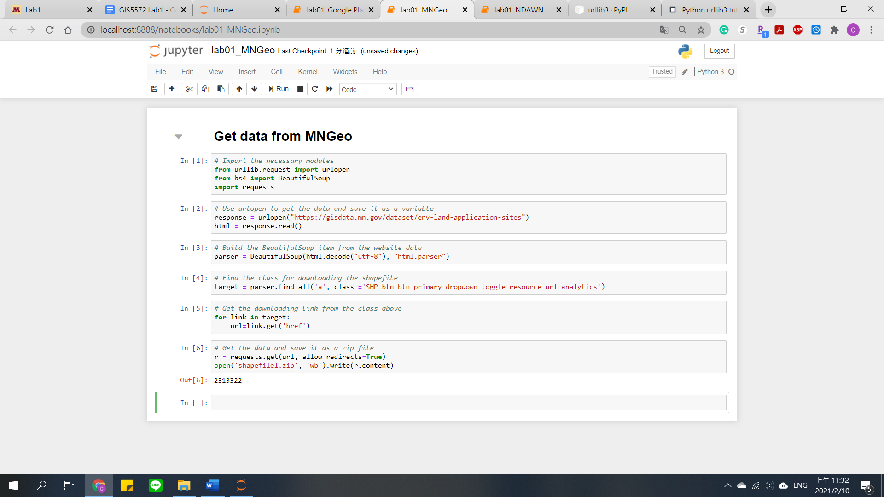

**Google Place**

In this API, I use its text search tool and find the results URL includes my searching words. After adding my API Key behind the URL, I can get a script code page. The page includes the information I search but it not easy to read, so I use beautifulsoup to deal with it and catch the necessary data. In the lab, I search the Japanese restaurant near me and get their name and address from the API to save it as a CSV file.

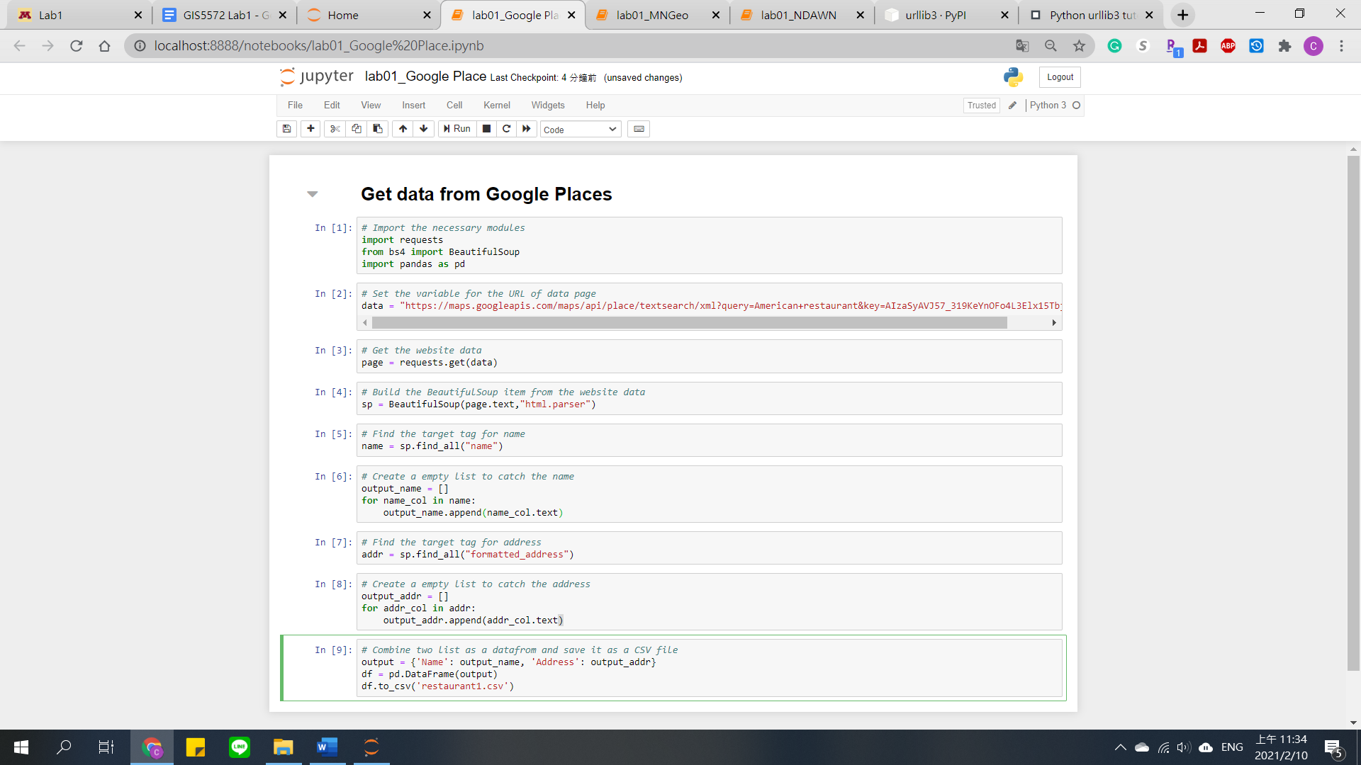

**Discussion and Conclusion**

After doing this lab, I become more familiar with the model of API and how to analyze its source code. The practice of getting the data programmatically is useful for me. I think it is an efficient way to get lots of data, moreover, dynamically to refresh the downloading data. It can be used in the project that needs to show some in time data, like weather, traffic, and wildfire. I hope I can use the parsing more familiar and apply it in my project in the future.

**References**

Bodnar, J. (2020, July 6). Python urllib3 tutorial - accessing web resources via HTTP. ZetCode. <https://zetcode.com/python/urllib3/>

Wang, G. T. (2018, February 4). Python 使用 Beautiful Soup 抓取與解析網頁資料，開發網路爬蟲教學 - 頁2，共3. G. T. Wang. https://blog.gtwang.org/programming/python-beautiful-soup-module-scrape-web-pages-tutorial/2/

**Self-score**

|  |  |  |  |
| --- | --- | --- | --- |
| **Category** | **Description** | **Points Possible** | **Score** |
| **Structural Elements** | All elements of a lab report are included **(2 points each)**:  Title, Notice: Dr. Bryan Runck, Author, Project Repository, Date, Abstract, Problem Statement, Input Data w/ tables, Methods w/ Data, Flow Diagrams, Results, Results Verification, Discussion and Conclusion, References in common format, Self-score | 28 | 28 |
| **Clarity of Content** | Each element above is executed at a professional level so that someone can understand the goal, data, methods, results, and their validity and implications in a 5 minute reading at a cursory-level, and in a 30 minute meeting at a deep level **(12 points)**. There is a clear connection from data to results to discussion and conclusion **(12 points)**. | 24 | 23 |
| **Reproducibility** | Results are completely reproducible by someone with basic GIS training. There is no ambiguity in data flow or rationale for data operations. Every step is documented and justified. | 28 | 27 |
| **Verification** | Results are correct in that they have been verified in comparison to some standard. The standard is clearly stated **(10 points)**, the method of comparison is clearly stated **(5 points)**, and the result of verification is clearly stated **(5 points)**. | 20 | 19 |
|  |  | 100 | 97 |